课后例句 Unit 5

Reading 1：

表示超纲词

1. Three generations of fishermen conduct an ***epic(漫长而艰难的)*** struggle against nature, fate, and society in this moving tale.
2. This island is a place of great adventures and ***epic(英雄的；英勇的；史诗般的 )***tales, inhabited by five tribes.
3. We camped that night in a shallow valley ***amid(在…之中；被…环绕)*** low hills covered with green pine trees.
4. The dollar has fallen in value ***amid(在（嘈杂、纷乱的时间）中（用于书面语或新闻报道中）)*** rumors of weakness in the US economy.

|  |  |
| --- | --- |
| in the middle of or during sth, especially sth that causes excitement or fear 在…过程中；在…中 | He finished his speech amid tremendous applause.  他在雷鸣般的掌声中结束了演讲。  The firm collapsed ***amid allegations of fraud.***  该公司在一片欺诈的指责声中倒闭了。  ● A senior leader cancelled a trip to Britain yesterday ***amid growing signs of a possible political crisis.***..  爆发政治危机的迹象日趋明显，一位高级领导人昨天取消了预定的英国之行。  ● Children were changing classrooms ***amid laughter and shouts.***  孩子们在欢笑声和喊叫声中换教室。 |
| surrounded by sth 在…中；四周是 | The hotel was in a beautiful position ***amid lemon groves.***  旅馆位于柠檬树丛之中，优美宜人。  .a tiny bungalow ***amid clusters of trees***  在树丛中的一间小平房 |

1. For centuries, the Rocky Mountains have captivated visitors with their ***jagged(凹凸不平的；锯齿状的)*** peaks, magnificent waterfalls, and blue lakes.

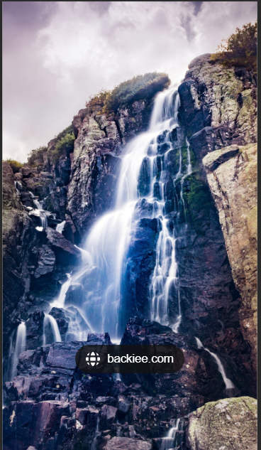

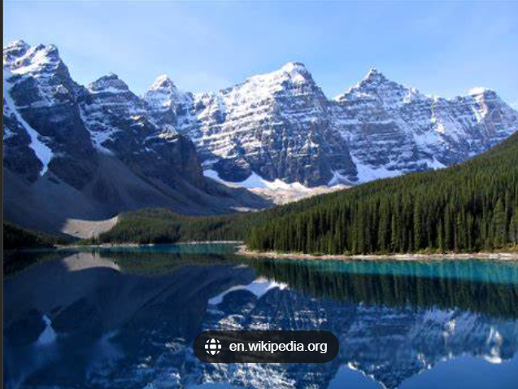

1. Just as the Sun began to break through an early-morning ***haze(烟雾，霾)***, I spotted three horses on a hill.

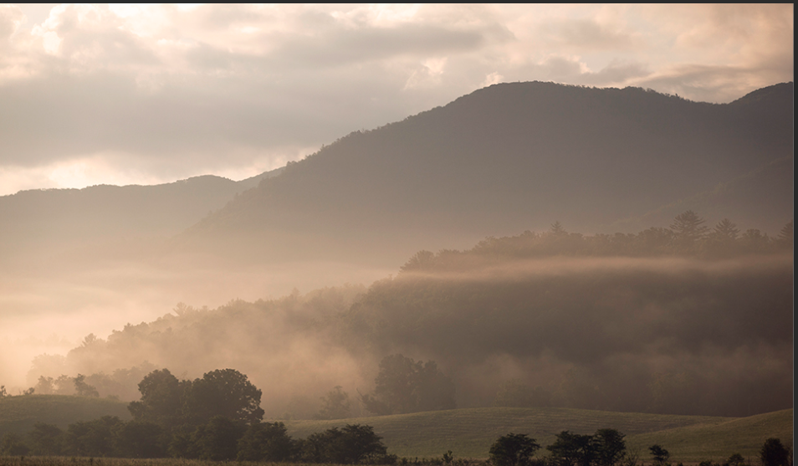

1. The light of the setting Sun ***tinges(着淡色于...；使带有一点（情绪、特质等）)*** the buildings with delicate colors.



1. The bright yellow ***shade((色彩的)浓淡，深浅，色度)*** is meant to evoke the optimistic promise of a sunshine-filled day.





1. I spent most of the day walking on the shore or reading a novel in the ***shade(背阴处；阴凉处)*** of a large umbrella.



1. My ***abiding( (感情或信念等)长久的，持久的)*** memory is of him watering his plants in the garden on sunny afternoons.

abide v

|  |  |
| --- | --- |
| [动词 + 名词短语] can't/couldn't ~ sb/sth to dislike sb/sth so much that you hate having to be with or deal with them （十分厌恶而）不能容忍，无法容忍 (bear, stand  ) | I can't abide people with no sense of humour.  我讨厌和没有幽默感的人打交道。  He couldn't abide the thought of being cooped up in an office.  一想到就觉得受不了。  ● I can't abide people who can't make up their minds... 我受不了优柔寡断的人。  ● She couldn't abide his success.  她见不得他成功。 |
| [动词 + 副词或介词短语](old use,or formal) to stay or live in a place 逗留；停留；居留；居住 | May joy and peace abide in us all.  愿我们大家都欢乐平安。 |

1. He is internationally recognized as a distinguished ***scholar（（尤指精于一门文科学问的）学者）*** in the field of Chinese studies.
2. Local people have to obey their ***conquerors（征服者）*** because they want to go on living.
3. The vehicle ***swerved（通常为了避免碰撞）突然转向一边*** off the road, hit a lamppost and rolled several times before catching fire.

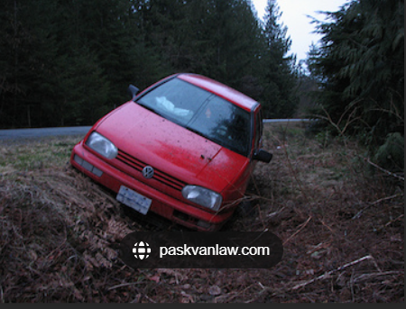

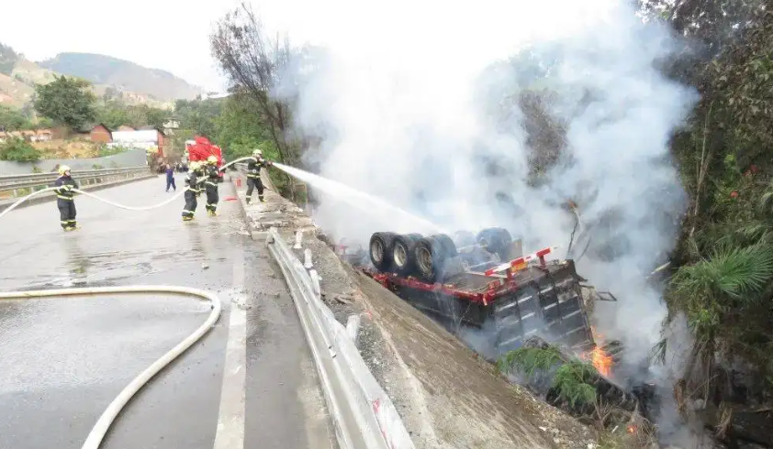

1. The performer shook, jumped and ***shimmied一摆一动地走（移动）*** in perfect motion, spurring the crowd to rise in an emotional applause.
2. Hundreds of trucks full of fruit and vegetables ***trundle（使）缓慢移动（滚动）*** across the border each day.
3. caravan

1）尤指穿越沙漠地带的旅行队，商队

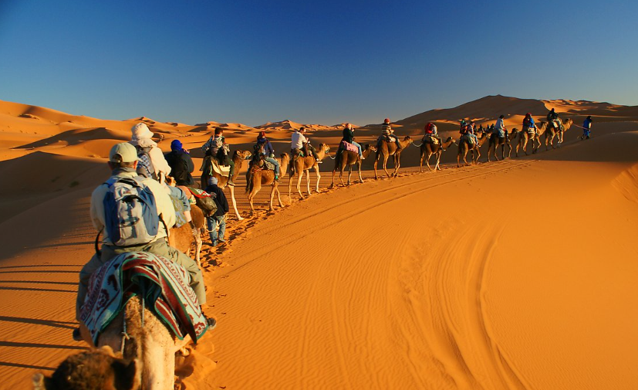

2）（AmE trailer） (带有食宿设备的)旅行拖车

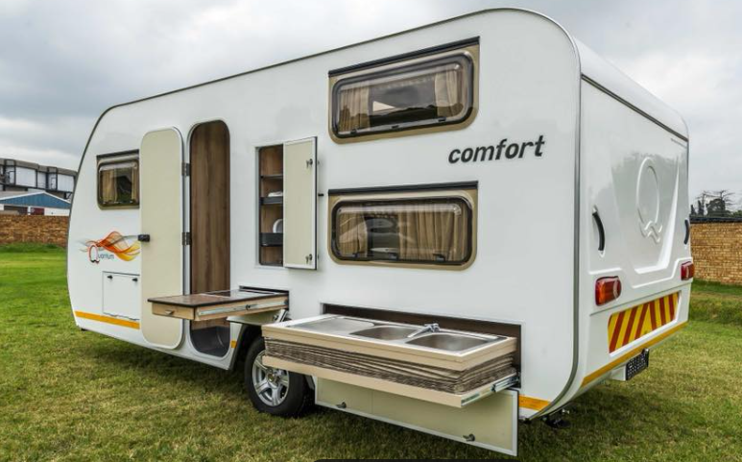

（讲练习）

1. spice 香料



1. A 25-year-old man was ***felled(（用力）击倒（某人）)*** by that boxer with a single punch.
2. Fifteen million trees were ***felled(砍伐（树木）)*** by the Great Storm which hit the south of England in 1987.
3. These birds are able to survive the ***perils(（某活动或情况的）危险，凶险)*** of the Arctic winter.
4. This was the second time that he had put his life in ***peril(巨大的危险（尤指受损或被杀）)*** to rescue someone at risk of drowning.

|  |  |
| --- | --- |
| [不可数名词] serious danger 严重危险 | The country's economy is now in grave peril.  现在，这个国家的经济陷入了严重危机。  ● ...the perils of the sea... 海洋的凶险  ● In spite of great peril, I have survived...  虽然处境非常危险,我还是挺过来了。 |
| [可数名词, 常用复数] ~ (of sth) the fact of sth being dangerous or harmful 祸害；险情 | a warning about the perils of drug abuse  对吸毒之害的警告 |

perilous: (literary) very dangerous 危险的；艰险的 (hazardous)

The road grew even steeper and more perilous.

a perilous journey across the war-zone.

We came perilously close to disaster. 我们险些出了大乱子。

造句：

1. It should be noted that some parts of the world seem to be experiencing ***climatic(气候的)*** changes.
2. They crossed the bridge and ***traversed(跨过；穿过；横越；横穿)*** the road out into the open country.
3. They warned us that the northern half of the island was controlled by ***hostile(敌人的；敌方的)*** forces.
4. Rebecca was very ***hostile(怀有敌意的；敌对的；不妤的)*** toward us and made it clear she didn't want our help.

|  |  |
| --- | --- |
| 1. ~ (to/towards sb/sth) very unfriendly or aggressive and ready to argue or fight 敌意的；敌对的 | The speaker got a hostile reception from the audience.  演讲人遭到了听众喝倒彩。  She was openly hostile towards her parents.她公然对抗她的父母。 |
| 1. ~ (to sth) strongly rejecting sth 坚决否定；强烈反对 (opposed to) | hostile to the idea of change 强烈反对变革 |
| 1. making it difficult for sth to happen or to be achieved 有阻碍的；不利的 | hostile conditions for plants to grow in  不利于植物生长的环境 |
| 1. belonging to a military enemy 敌军的；敌人的 | hostile territory敌方领土 |
| 1. (business 商) (of an offer to buy a company, etc. 收购公司等的要約) not wanted by the company that is to be bought 不受（被购公司）欢迎的；敌意的 | a hostile takeover bid  出价敌意收购 |

[ ] Many people felt he would be hostile to the idea of foreign intervention...

[ ] The West has gradually relaxed its hostile attitude to this influential state

[ ] Drinking may make a person feel relaxed and happy, or it may make her hostile, violent, or depressed.

[ ] The prisoner eyed him in hostile silence.

[ ] some of the most hostile climatic conditions in the world.

[ ] If this round of talks fails, the world's trading environment is likely to become increasingly hostile.

[ ] Kingfisher launched a hostile bid for Dixons.

[ ] The city is encircled by a hostile army.

[ ] They were in hostile territory.

1. The new oil contracts will amount to a half billion dollars' worth of foreign investment in their ***territory(领土；版图；领地)***.

territorial area/water/air

E.T. extraterrestrial ['ɛkstrətə'rɛstrɪəl] adj. 地球外的 n. 外星人

terrestrial [tə'rɛstrɪəl] adj. 地球的；陆地的，陆生的； n. 陆地生物；地球上的人

terraneous [te'reɪnɪəs]adj.陆生的，生存于陆地上的

terrace [ˈtɛrɪs] n.台阶，阶地；阳台；梯田

terrain [təˈren] n.地形，地势； 地面，地带

inter [ɪnˈtə：] vt.埋，葬 interment

disinter [,dɪsɪn'tɝ] vt. 掘出；发掘；显露 disinterment

Mediterranean [ˌmɛdətəˈreɪniən] n. 地中海adj. 地中海的

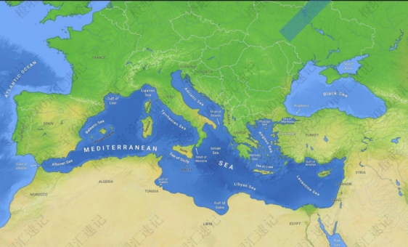

subterrane ['sʌbtə,ren] n. 下层；地下室，洞穴

subterraneous 地下的

superterrene 地面上的，地上的

terramycin [ˌterə'maɪsɪn] n.土霉素 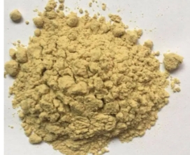

1. He urged the United States to ***persist(坚持；执意)*** with its efforts to bring about peace.
2. After walking five miles, they had worked up a great ***thirst(渴；口渴)*** and decided to stop for water.
3. To put it another way, the analysis lacks both a sense of humanism and a theory of ***ideology(思想（体系）；思想意识).***

[可数名词, 不可数名词] (sometimes disapproving) (pl. -ies)

|  |  |
| --- | --- |
| a set of ideas that an economic or political system is based on 思想（体系）；思想意识 | Marxist/capitalist ideology 马克思主义 / 资本主义思想体系 |
| a set of beliefs, especially one held by a particular group, that influences the way people behave 意识形态；观念形态 | the ideology of gender roles 性别角色的观念形态  alternative ideologies 非传统的意识形态 |

1. There will always be "lost in translation" moments, but that's part of the ***allure(诱惑；魅力；吸引力)*** of foreign travel.

sexual allure 性诱惑

the allure of the big city 大城市的吸引力

● It's a game that has really lost its allure. 这是一项的确已失去了魅力的游戏。

● ...the captivating allure of Isabelle Adjani. 伊莎贝拉·阿佳妮令人倾倒的魅力

1. The ***intrinsic(固有的; 内在的; 本身的)*** value of a coin is the value of the metal it is made of.
2. There are plenty of ways to see the country this summer, but few can beat the ***romance(传奇色彩；浪漫情调)*** of traveling on a steam train.
3. Hemingway's ***romance(罗曼史)*** with his nurse inspired him to write *A Farewell to Arms.*
4. His refusal to work late was ***interpreted(把⋯理解（解释）为)***as a lack of commitment to the company.
5. She couldn't speak much English so her children had to ***interpret(口译)*** for her while traveling in the UK.

[动词 + 名词短语] ~ sth (as sth) to decide that sth has a particular meaning and to understand it in this way 把…理解为；领会

I didn't know whether to interpret her silence as acceptance or refusal.

The data can be interpreted in many different ways. 这份资料可以从多方面解读。

（讲练习）

1. The feelings that arise in that condition are simpler, more understandable, and more ***durable(持久的)***.
2. Fine bone china is very practical due to the fact that it is strong and ***durable(耐用的).***
3. The new model is a ***testament(是⋯的证据；是⋯的证明)*** to the skill and dedication of the workforce.

（= testimony）

● Braka's house, just off Sloane Square, is a testament to his Gothic tastes...

布拉卡那幢紧靠斯隆广场的房子是他喜好哥特式建筑的一个证据。

● The fact that these scandals are now public is testament to the relative openness of America's government.

这些丑闻如今公之于众的事实说明了美国政府的相对透明。

The new model is a testament to the skill and dedication of the workforce.

这种新型产品显示了全体员工的技术水平和敬业精神。

1. As children, we were ***dazzled(使…倾倒)*** by my uncle's good looks and charm.
2. Drivers are supposed to slow down or pull over when they are ***dazzled ((因强光、闪烁等）使…目眩；使…眼花缭乱)*** by bright sunlight. (= blind)



|  |  |
| --- | --- |
| blind | He was momentarily dazzled by the strong sunlight.  强烈的阳光使他一时睁不开眼。 |
| [动词 + 名词短语] to impress sb a lot with your beauty, skill, etc. （美貌、技能等）使倾倒，使赞叹不已，使眼花缭乱 | He was dazzled by the warmth of her smile. 她那温柔的微笑使他神魂颠倒。 |

He shielded his eyes against the dazzling declining sun.

He gave Alberg a dazzling smile. 他冲着阿尔伯格粲然一笑。

a dazzling array of talent 耀眼的大批天才

1. They are hoping to ***retrace(重走（别人走过的路程）)*** the epic voyage of Christopher Columbus.
2. By trailing a thread behind them spiders are able to drop from any height to the ground and to ***retrace(顺原路返回；折返)*** their steps with certainty to a particular spot.
3. Lingyin Temple is a famous ***Buddhist（佛教的)*** temple situated in the northwest of Hangzhou.

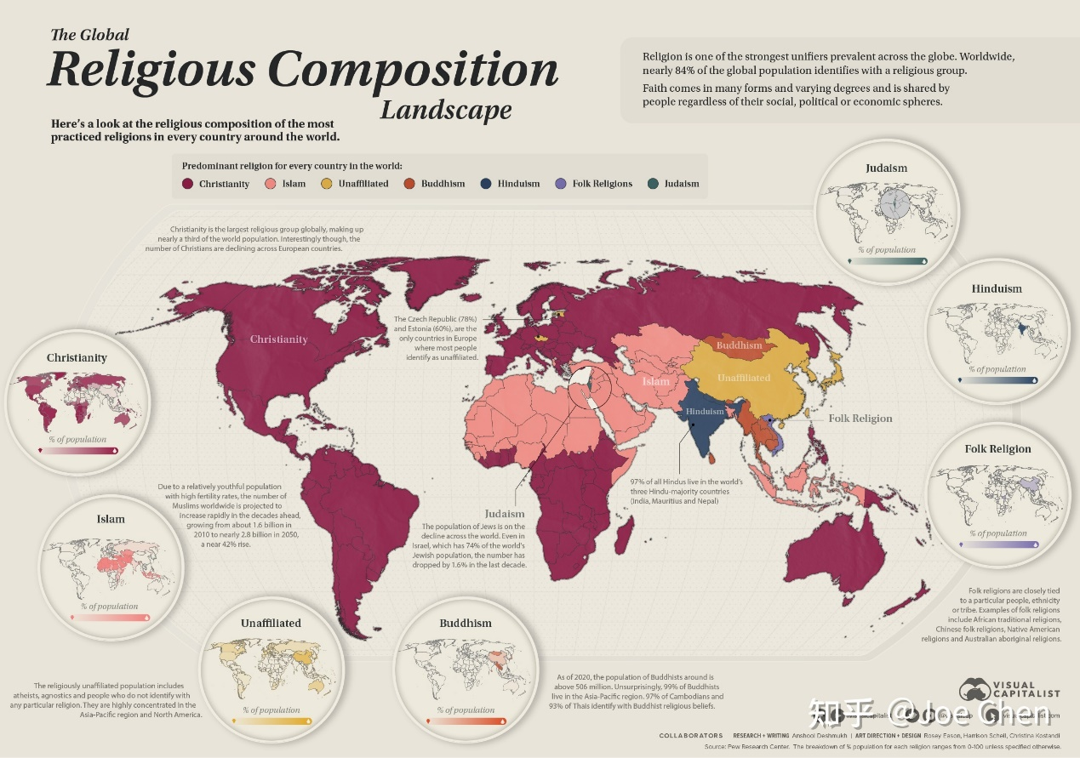

Christianity基督教, Islam, Judaism 犹太教, Hinduism印度教, Buddhism, Folk Religion, unaffiliated https://zhuanlan.zhihu.com/p/490853114

基督教、伊斯兰教、犹太教、印度教、佛教、

1. This ***grotto（小洞穴)*** houses the most exquisite stone sculptures from the Tang Dynasty. (注意拼写) 复数？-s, -es
2. The crowd ***drifted（缭缓移动；缓慢行走）*** away from the scene of the accident.
3. As our boat ***drifted（漂流；漂移）*** down the river, many children ran along the shore waving at us.
4. Yosemite National Park is an area of outstanding ***scenic（景色优美的）*** beauty and great wilderness value.
5. Enormous cloud ***formations（（岩石或云朵的）形成物；形状）*** dominate the landscape on a hot, humid summer's day.
6. An agreement on the ***formation（构成；组成）*** of a new government was reached on June 6.

word formation

1. The beach ***stretches（延伸；绵延）*** for more than two miles, backed by grassy dunes and sweet-smelling pine forest.

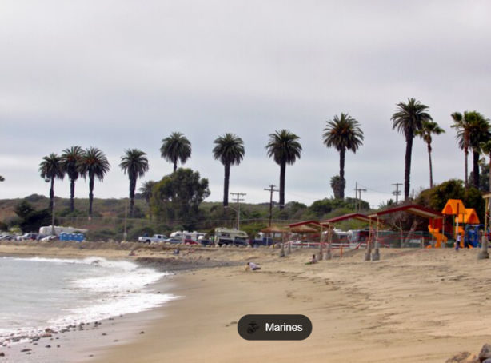

1. Once ***stretched（使）变大；（使）变松；拉长）***, the elastic band will not return to its original length.



1. A loose dog is at the risk of falling or being ***catapulted （把…弹（射）出去）***out of the truck bed.

词根 pel/puls 驱使，推动

pull， push

[pʊʃ] vt.& vi.推，推动

pulse [pʌls] n. 脉冲；脉搏 vi. 跳动，脉跳

impel[ɪmˈpel] vt.推动、推进；驱使；迫使

impulse n.推动（力）；（内心的）冲动

impulsion n.冲动；推进

impulsive adj.冲动的；由冲动造成的



dispel [dɪ'spɛl] vt. 驱散，驱逐；消除（烦恼等）

expel [ɪk'spɛl] vt. 驱逐；开除

expeller n.逐出者，开除者

expellee n.被逐出国外者，被开除者

compel [kəmˈpel] vt.强迫，迫使； 强制发生

compulsion n.强迫，强制

compulsive adj.强制性的，强迫的

compulsory adj.必须做的，强制性的； 义务的； 必修的

compulsory education 义务教育

compulsory service 义务兵役

compulsory execution 强制执行

compulsory purchase 强制性购买

repel [rɪˈpel] vt.击退；驱赶，抵制； 使厌恶；

repellent adj.击退的；令人不愉快的，令人厌恶的

repulsive adj.令人厌恶的，令人不愉快的；击退的

repulse v.反击，击退；拒绝，回绝

repulsion n.击退；厌恶，反感



propel [prəˈpel] vt.推进； 推动； 驱动； 驱使 v.推进

propellant adj.推进的 n.推动者（物）；（火箭等的）推进燃料

propeller n.推进器；螺旋桨

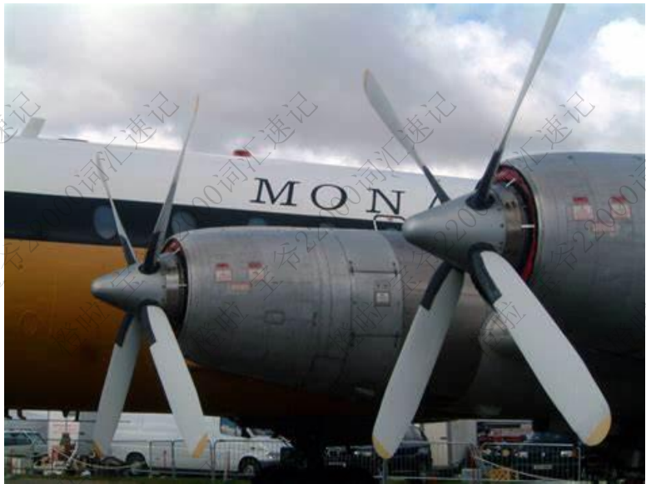

1. You might gaze at the Grand Canyon with ***awe（崇敬；赞叹）***，marveling at its beauty and fearing its death.

[不可数名词] feelings of respect and slight fear; feelings of being very impressed by sth/sb 敬畏；惊叹

awe and respect 敬畏和尊敬

awe and wonder 敬畏和惊奇

He speaks of her with awe . 他谈到她时肃然起敬。

‘It's magnificent, ’ she whispered in awe .

● She gazed in awe at the great stones... 她惊叹地盯着那些巨石。

● His fellow officers regarded him with awe as some sort of genius... 很敬畏他，视他如天才。

（讲练习）

1. We cannot cure the world of ***sorrows（令人悲伤的事；不幸）***, but we can choose to live in joy.
2. The president expressed his deep ***sorrow（悲伤，悲痛）*** over the bombing deaths.
3. The report calls for a ban on the import of ***hazardous（危险的；有害的）*** waste.
4. That's probably the most bare, ***bleak（无遮掩的；荒凉的；索然无味的***）, and inhospitable island I've ever seen.

bleak

|  |  |
| --- | --- |
| (of a situation 状况) not encouraging or giving any reason to have hope 不乐观的；无望的；暗淡的 | a bleak outlook/prospect 暗淡的前景 / 前途  The future looks bleak for the fishing industry. 渔业前景暗淡。  The medical prognosis was bleak. 医疗预后不良。 |
| (of the weather 天气) cold and unpleasant 阴冷的  (of a place 地方) exposed, empty, or with no pleasant features 无遮掩的；荒凉的；索然无a bleak landscape/hillside/moor 荒芜的景色 / 山坡 / 野地 | a bleak winter's day 一个阴冷的冬日  bleak concrete housing 索然乏味的混凝土住宅群 |
| （人）无精打采的，沮丧的，阴郁的 If someone looks or sounds bleak, they look or sound depressed, as if they have no hope or energy. | The weather can be quite bleak on the coast.  His face was bleak.. |

[ ] The immediate outlook remains bleak...

[ ] Many predicted a bleak future.

[ ] The island's pretty bleak.

[ ] ..bleak inner-city streets.

[ ] Alberg gave him a bleak stare.

1. They had to overcome ***formidable（令人敬畏的；可怕的）*** obstacles during their journey.

formidable

In debate he was a formidable opponent. 在辩论中他是位难应付的对手。

She has a formidable list of qualifications. 她有一长串令人敬畏的资历。

The two players together make a formidable combination. 这两个队员配对儿，难以对付。

The task was a formidable one. 这任务非常艰巨。

They had to overcome formidable obstacles. 他们得克服重重障碍。

formidably: adv.

He now has the chance to prove himself ***in a formidably difficult role.***

现在他的任务十分艰巨，有机会证明自己的能力。

She's ***formidably intelligent.***

她聪明绝顶。

1. Penguins employ cooperative behaviors in order to deal with an incredibly ***harsh （恶劣的；艰苦的；严峻的）***environment.
2. The solar cooker looks impressive, with mirrors designed to catch the ***harsh（刺眼的；耀眼的）*** sunlight, focusing their power to create intense heat.
3. Millions of people in that region are threatened with ***starvation（饥饿；挨俄；饿死）*** as a result of drought and poor harvests.
4. The ancient ***civilizations（文明（社会））*** of Central and Latin America were founded upon corn.
5. It would be helpful if you were to ***precede（先于…（发生或出现））*** the report with an introduction.

反义：succeed (= follow)

Who succeeded Kennedy as President? 接替肯尼迪任总统的是谁？

Their early success was succeeded by a period of miserable failure. 他们起初获得成功，但随后有一段惨痛失败的时期。

1. Running a marathon is seen by many people as the ultimate test of human ***endurance（（忍）耐力）***.
2. Dean ***tricked（用计诱使某人做某事）*** the old lady into giving him 800 pounds, claiming that he would invest it for her.
3. When Captain Cook ***set sail（起航） for*** the Pacific, he was heading to parts of the world that were little-known. Set sail from/to/for ...
4. We struck up a conversation, ***in the course of （在⋯期间）***which it emerged that he was a sailing man. during/in/throughout the course of
5. The rescue team also had bad weather conditions to ***contend with（（不得不）处理问题，对付困境）***.